|  |
| --- |
| Experiment No. 8 |
| Single Source Shortest Path using Dynamic Programming  (Bellman-Ford Algorithm) |
| Date of Performance: |
| Date of Submission: |

**Experiment No: 8**

**Title:** Single Source Shortest Path: Bellman Ford

**Aim:** To study and implement Single Source Shortest Path using Dynamic Programming: Bellman Ford

**Objective:** To introduceBellman Ford method

**Theory:**

Given a graph and a source vertex source in graph, find shortest paths from src to all vertices in the given graph. The graph may contain negative weight edges.We have discussed Dijkstra’s algorithm for this problem. Dijkstra’s algorithm is a Greedy algorithm and time complexity is O(VLogV) (with the use of Fibonacci heap). Dijkstra doesn’t work for Graphs with negative weight edges, Bellman-Ford works for such graphs. Bellman-Ford is also simpler than Dijkstra and suites well for distributed systems. But time complexity of Bellman-Ford is O(VE), which is more than Dijkstra.

**Example:**

Let the given source vertex be 0. Initialize all distances as infinite, except the distance to the source itself. Total number of vertices in the graph is 5, so all edges must be processed 4 times.

Bellman–Ford Algorithm Example Graph 1

Let all edges are processed in the following order: (B, E), (D, B), (B, D), (A, B), (A, C), (D, C), (B, C), (E, D). We get the following distances when all edges are processed the first time. The first row shows initial distances. The second row shows distances when edges (B, E), (D, B), (B, D) and (A, B) are processed. The third row shows distances when (A, C) is processed. The fourth row shows when (D, C), (B, C) and (E, D) are processed.

Bellman–Ford Algorithm Example Graph 3

The second iteration guarantees to give all shortest paths which are at most 2 edges long. The algorithm processes all edges 2 more times. The distances are minimized after the second iteration, so third and fourth iterations don’t update the distances.

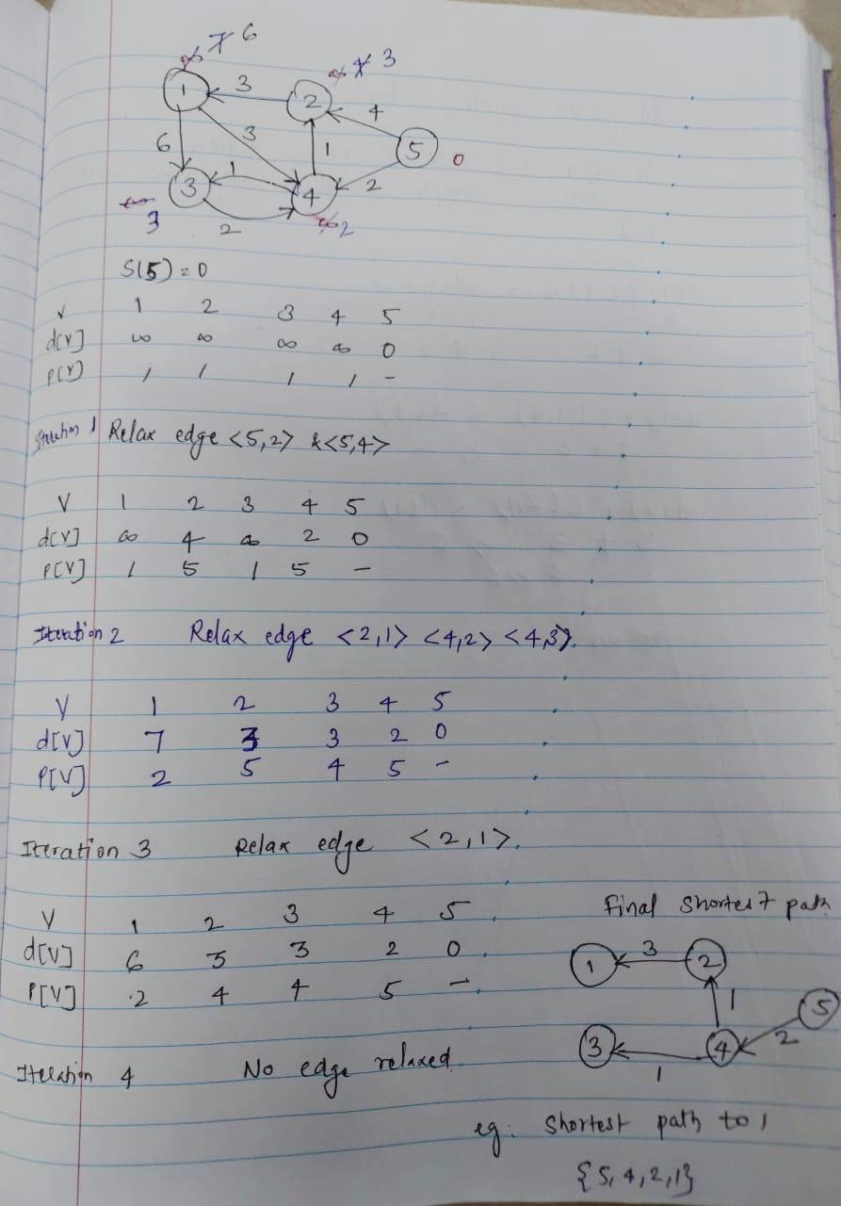

**Algorithm:**

function Bellman_Ford(list vertices, list edges, vertex source, distance[], parent[])  
   
// Step 1 – initialize the graph. In the beginning, all vertices weight of  
// INFINITY and a null parent, except for the source, where the weight is 0  
   
for each vertex v in vertices  
    distance[v] = INFINITY  
    parent[v] = NULL  
   
distance[source] = 0  
// Step 2 – relax edges repeatedly  
    for i = 1 to V-1    // V – number of vertices  
        for each edge (u, v) with weight w  
            if (distance[u] + w) is less than distance[v]  
                distance[v] = distance[u] + w  
                parent[v] = u  
   
// Step 3 – check for negative-weight cycles  
for each edge (u, v) with weight w  
    if (distance[u] + w) is less than distance[v]  
        return “Graph contains a negative-weight cycle”  
   
return distance[], parent[]

**Output:**

Shortest path from source (5)

Vertex 5 -> cost=0 parent=0

Vertex 1-> cost=6 parent=2

Vertex 2-> cost=3 parent=4

Vertex 3-> cost =3 parent =4

Vertex 4-> cost =2 paren=5

**Implementation:**

**Code:**

#include <stdio.h>

#include <stdlib.h>

#include <limits.h>

#define INF INT_MAX

#define MAX_VERTICES 100

#define MAX_EDGES 100

// Structure to represent a weighted edge

struct Edge {

    int source, destination, weight;

};

// Structure to represent a graph

struct Graph {

    int V, E;

    struct Edge edge[MAX_EDGES];

};

// Function to print the solution

void printSolution(int dist[], int n) {

    printf("Vertex   Distance from Source\n");

    for (int i = 0; i < n; ++i)

        printf("%d \t\t %d\n", i, dist[i]);

}

// Bellman-Ford algorithm

void BellmanFord(struct Graph* graph, int source) {

    int V = graph->V;

    int E = graph->E;

    int dist[V];

    // Initialize distances from source to all other vertices as INFINITE

    for (int i = 0; i < V; i++)

        dist[i] = INF;

    dist[source] = 0;

    // Relax all edges |V| - 1 times

    for (int i = 1; i <= V - 1; i++) {

        for (int j = 0; j < E; j++) {

            int u = graph->edge[j].source;

            int v = graph->edge[j].destination;

            int weight = graph->edge[j].weight;

            if (dist[u] != INF && dist[u] + weight < dist[v])

                dist[v] = dist[u] + weight;

        }

    }

    // Check for negative-weight cycles

    for (int i = 0; i < E; i++) {

        int u = graph->edge[i].source;

        int v = graph->edge[i].destination;

        int weight = graph->edge[i].weight;

        if (dist[u] != INF && dist[u] + weight < dist[v]) {

            printf("Graph contains negative weight cycle");

            return;

        }

    }

    // Print the distances

    printSolution(dist, V);

}

int main() {

    struct Graph* graph = (struct Graph*)malloc(sizeof(struct Graph));

    graph->V = 5;  // Number of vertices

    graph->E = 8;  // Number of edges

    // Add the edges

    graph->edge[0].source = 0;

    graph->edge[0].destination = 1;

    graph->edge[0].weight = -1;

    graph->edge[1].source = 0;

    graph->edge[1].destination = 2;

    graph->edge[1].weight = 4;

    graph->edge[2].source = 1;

    graph->edge[2].destination = 2;

    graph->edge[2].weight = 3;

    graph->edge[3].source = 1;

    graph->edge[3].destination = 3;

    graph->edge[3].weight = 2;

    graph->edge[4].source = 1;

    graph->edge[4].destination = 4;

    graph->edge[4].weight = 2;

    graph->edge[5].source = 3;

    graph->edge[5].destination = 2;

    graph->edge[5].weight = 5;

    graph->edge[6].source = 3;

    graph->edge[6].destination = 1;

    graph->edge[6].weight = 1;

    graph->edge[7].source = 4;

    graph->edge[7].destination = 3;

    graph->edge[7].weight = -3;

    BellmanFord(graph, 0);  // Source vertex is 0

    free(graph);

    return 0;

}

Output:

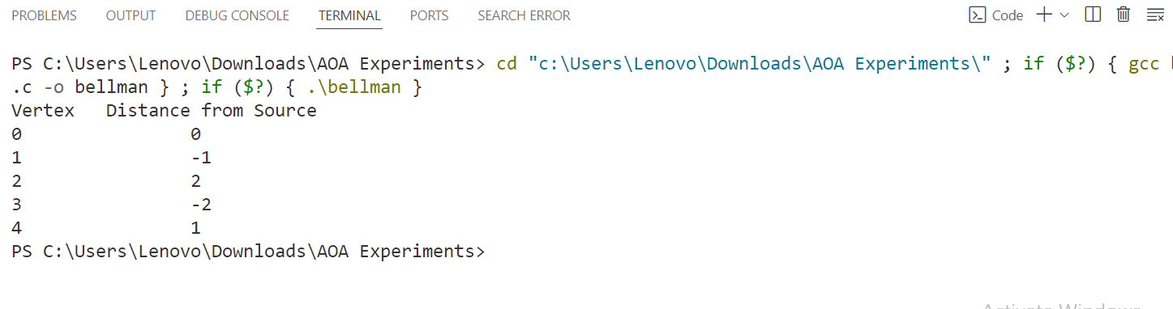

**Conclusion:**

In conclusion, the Bellman-Ford algorithm efficiently computes the shortest paths from a single source vertex to all other vertices in a weighted graph, even in the presence of negative weight edges, as long as there are no negative weight cycles reachable from the source vertex.

The algorithm iteratively relaxes the edges of the graph |V| - 1 times, where |V| is the number of vertices, ensuring that the shortest path distances are computed accurately. After the relaxation process, it checks for negative weight cycles by iterating through all edges again. If a shorter path is found during this step, it indicates the presence of a negative weight cycle in the graph.

This implementation of the Bellman-Ford algorithm initializes the distances from the source vertex to all other vertices as infinity initially, except for the source vertex itself, which is set to 0. It then iteratively updates the distances based on the edge weights, ensuring that the shortest path distances are computed correctly.